Phase 6 Summary
Input System Construction + Camera Integration + Image Acquisition Verification.

Phase Objective
In the previous phase, the system had already completed:
  - Construction of the PC-side AI inference capability;
  - Establishment of a stable MCU $↔$ PC UART communication closed loop;
  - MCU $↔$ PC closed-loop verification based on “local image files”.

However, the essence of the previous system was still:
A simulated input system.

Specifically:
  - Image data originated from local PC files;
  - The MCU did not participate in data generation;
  - The camera acquisition path had not yet been established.

Therefore, although the system already possessed the logical closed loop of:
“Image → AI Inference → Result Output”

The closed loop still did not cover one of the most critical parts of a real embedded scenario:
Data acquisition

In other words:
The current system was capable of processing data , but incapable of generation data. It was fundamentally only a verification system.

Based on this assessment, the core objective of this phase was defined as:
Construction image input capability on the embedded side and achieving the minimum closed-loop verification of:
“Trigger → Image Acquisition → Data Output”

Overall System Design Concept
In the overall architecture of this project, the ultimate goal is not merely the implementation of a single function, but the gradual construction of a complete embedded visual perception system.

To control development complexity while ensuring phased verification and engineering feasibility, the system was divided into three progressive subsystems:
  - Button-triggered image capture system (engineering verification system);
  - Periodic image capture system ( semi-real-time system);
  - Real-time continuous detection system ( target system, not guaranteed to be completed).

This division follows the following engineering logic:
“Discrete triggering” → “periodic triggering” → “continuous perception”

The corresponding input control mechanisms are:

Stage | Input Type | Characteristics
Button Trigger | Human timing | Highly controllable, used for closed-loop verification
Periodic Trigger | Timer-driven | Semi-real-time system
Real-Time System | Continuous data stream | Final target system

Under this framework, the role of Phase 6 was defined as:
Completing the fundamental capability construction of “button triggering + camera acquisition”, providing the minimum verifiable closed loop for future system evolution.

Therefore, this phase first focused on button event modeling, followed by camera integration, ultimately forming a complete logical closed loop.

Construction of the Button Trigger System
Before implementing the “button-triggered image capture system”, a verification project was first established using button-triggered LED toggling to complete:
The abstraction of “button input → system event triggering”

Design Objective
Convert mechanical button input into a stable and reusable software event, and verify event correctness through observable outputs.

Implementation Method
The following mechanisms were adopted:
  - State machine;
  - Software debounces.

The following event model was constructed:
KEY_IDLE → PRESS → RELEASE → EVENT
An event is triggered only after a complete “press + release” operation.

Event Response Design
To verify the correctness of event triggering, an LED was introduced as an observable output:
Each valid button event triggers one LED state toggle.

That is:
One complete button operation (press + release) corresponds to one LED toggle.

The main loop logic was implemented as:
if (BSP_KEY_ScanEvent() == 1)
{
BSP_LED_Toggle();
}
Verification Results
- Single click → LED toggles one;
- Long press → LED does not continuously toggle;
- Continuous clicking → LED toggles correctly without missing events;
- Idle state → LED remains stable.

Conclusion
A complete chain of:
“Button input → Event generation → Event response”
Was successfully established.

Mechanical button input was successfully abstracted into a stable software event and verified through LED output.

Camera System Integration Path
Camera integration in the phase did not directly proceed to image acquisition. Instead, a layered verification strategy was adopted and gradually advanced step by step.

Camera System Description
The project uses the OV2640 camera module as the image acquisition device.

The OV2640 has the following characteristics:
  - Supports JPEG image output (one-chip compression);
  - Uses DVP (parallel interface) data output;
  - Uses SCCB (I2C-compatible protocol) for register configuration;
  - Contains an internal ISP (Image Signal Processor) supporting automatic white balance, color adjustment, and related functions.

Within this system, the data path is :
OV2640 → DVP → DCMI → DMA → MCU Memory

The control path is:
MCU → SCCB → Camera Registers

The camera was selected primarily because:
Its JPEG output capability significantly reduces MCU-side image processing workload, making it suitable for resource-constrained embedded systems.

Establishment of the Control Path

Debugging Method Description
At the begging of this phase, due to the inability of the third-party ST-LINK module to correctly enter Debug mode – and in some cased even failing to support flashing through STM32CubeIDE – the system initially lacked online debugging capability.

Therefore, the early debugging approach relied on:
UART print debugging

Its basic workflow included:
  - Inserting log outputs at critical execution points;
  - Observing execution results through a serial terminal;
  - Analyzing problems based printed outputs.

This method was mainly used for:
  - I2C scan verification;
  - PCF8574 control validation;
  - Camera register readout verification.

Initial Stage

Camera Hardware Interface Analysis
The OV2640 module pins were analyzed one by one:
  - Data bus: D0 ~ D7;
  - Synchronization signals: VSYNC/HREF/PCLK;
  - Control signals: SCL/SDA/RESET/PWDN.

Combined with the development board schematic:
The DCMI data path (D0 ~ D7 + synchronization signals) was correctly connected to the STM32H743;
SCCB (SCL/SDA) was used for register configuration.
However, during actual debugging:
The camera could not be detected;
The camera ID could not be read.

Through schematic analysis, it was discovered that:
The camera PWDN pin was not directly connected to STM32 GPIO.

Instead, it was connected through the PCF8574 I2C IO expander.

That is:
STM32 → I2C → PCF8574 → P2 → Camera PWDN

As a result, the camera remained permanently in Power Down mode.

Solution Process
The control path was established layer by layer:
  - I2C scan → PCF8574 detection;
  - IO control → output verification;
  - Pull PWDN low → camera power-up;
  - SCCB communication → register access established.

During PCF8574 verification, the initial test used pull-byte writes:
Write 0x00 (all outputs low).

Observed behavior:
  - Camera ID could be successfully read;
  - The onboard buzzer was also triggered simultaneously.

This indicated:
The PCF8574 was not dedicated solely to camera control signals, but shared among multiple peripherals.

Specifically:
  - PWDN occupied only one IO bit;
  - Other IO were connected to peripherals such as the buzzer.

Further schematic analysis confirmed:
Camera PWDN was connected to the P2 pin of the PCF85674.

Therefore, the control method was optimized into:
Single bit control.
To avoid affecting other peripherals.

Final verification output:
PCF8574 write 0xFF OK
PCF8574 write 0xFB OK
PCF8574 write 0xFF OK
Experimental Result
The camera ID was successfully read:
0x2642
Conclusion
The PCF8574 is a shared IO expander used multiple peripherals:
- Bit-level control is required;
- The camera PWDN control path was correctly identified and stably established.

Exposure of Image Path Problems
After completing verification of the camera control path (SCCB), the system entered the image acquisition stage.

The objective of this stage was to verify whether DCMI + DMA could successfully acquire one complete frame of image data.

Experimental Process
The following preliminary tasks were first completed:
  - Construction of the camera initialization process (including initialization tables and staged initialization: Sensor/DSP/JPEG);
  - Verification that camera register could still be read and written correctly after initialization (ensuring initialization did not corrupt the device);
  - Construction of a DCMI + DMA single-frame acquisition framework (Snapshot mode);
  - Introduction of FrameEvent/Error callback mechanisms;
  - Implementation of a buffer inspection function for detecting JPEG SOI markers (FF D8).

Problem Investigation
The investigation proceeded systematically according to system layers.

- DMA Configuration Problem
- Phenomenon:
  - HAL_DCMI_Start_DMA returned failure immediately.
- Solution
  - DMA initialization configuration was supplemented and correct.
- Result:
  - DCMI startup succeeded;
  - However, image data still could not be acquired.
- DCMI Interrupt Problem
- Phenomenon
  - DCMI continuously entered TIMEOUT state.
- Analysis
  - Frame events might not have been correctly handled.
- Solution
  - NVIC interrupt configuration was manually added.
- Result:
  - TIMEOUT issue still persisted.

Signal-Level Analysis
To further locate the issue, GPIO signal sampling was used to directly observe camera output signals.

Observed results:
  - PCLK edge count ≥ 0 (high-frequency transitions existed);
  - VSYNC remained at a fixed logic level;
  - HREF (HSYNC) remained at a fixed logic level.

From these observations, the following conclusions could be drawn:
  - The camera had entered working state (PCLK existed);
  - Data was being output;
  - However, synchronization signals (VSYNC/HREF) were not being correctly recognized by the MCU.

At this stage, the system status was:
  - The MCU could control the camera (SCCB functioning normally);
  - The camera was outputting data (PCLK functioning normally);
  - But the MCU could not recognize frame boundaries.

Based on this assessment, the following additional attempts were made:
  - Adjusting PCLK polarity (Rising/Falling);
  - Trying different VSYNC/HSYNC polarity combinations.

Experimental results:
  - DCMI still remained in BUSY/TIMEOUT state;
  - Or entered DMA ERROR state.
At this point, it could be concluded that:
The only remaining abnormality was concentrated on VSYNC/HREF not being correctly recognized by the MCU.

Problem Analysis
The current issue should be classified as:
Synchronization signals not being correctly recognized or parsed
rather than:
Camera not functioning;
Data path disconnected.

Conclusion
The camera had already entered image output state, but the MCU could not correctly recognize frame synchronization signals.

The problem had been narrowed down to the synchronization signal path (VSYNC/HREF).
However, due to the limitations of UART-based debugging, the root cause still could not be identified at this stage.

Evolution of the Debugging Framework
Within the camera subsystem, UART-based debugging exhibited severe limitations:
  - Insufficient Information Granularity, UART debugging could not provide:
    - Real-time GPIO level observation;
    - Register state observation;
    - Timing behavior analysis.
  - Low Debugging Efficiency
    - Each modification required the entire flashing procedure to be repeated:
      - Build project in STM32CubeIDE → Open STM32 Programmer → Flash firmware
    - As a result:
      - Rapid trial-and-error debugging was impossible;
      - System iteration efficiency became extremely low.

As system complexity continued increasing, UART debugging was no longer capable of supporting further development.

After obtaining the STM32F407G-DISC1 development board, its onboard ST-LINK could be used as an external debugger.

At the same time, based on the following observations:
  - The current project still contained unresolved issues (VSYNC/HREF);
  - The existing project structure had become excessively complex;
  - Refactoring the original project into a Debug-capable architecture would require reconstruction effort approaching a full rewrite.

Therefore, the following decision was made:
Abandon the original project entirely and rebuild the debugging framework from scratch based on Debug-mode development.

Debugging Environment Description
During Debug-mode development, the external ST-LINK exhibited the following issues:
  - Target not responding
  - Variables could not refresh in real time.

The causes were identified as:
  - NRST was not connected (which would require cutting hardware solder bridges);
  - The debugging link was incomplete.

As a result:
Real-time observation capability remained partially limited.
But the debugging capability provided by Debug mode was still much better than UART debugging.

Establishment of the Image Acquisition Path
After completing verification of the camera control path and basic initialization procedures, the system entered the image acquisition stage.

The core objective of this stage was:
Verifying whether the MCU could successfully acquire and output one complete JPEG image frame.

Problem Reproduction and Root Cause Localization

Background and Source of the Problem
In the previous UART-debugging-based project, partial camera acquisition functionality had already been implemented.

However, one critical unresolved issue always remained:
Abnormal VSYNC/HREF signals

Due to the limitations of UART debugging, the issue could not be located at that time.

Problem Reproduction Under Debug Environment
After rebuilding the project under Debug mode in this phase, all previous work was reproduced at first:
  - I2C communication verification;
  - PCF8574 verification;
  - PWDN control;
  - SCCB communication;
  - Camera ID acquisition.

After confirming that all control paths were functioning correctly, image output signals were observed again:
  - PCLK: no output (initially);
  - VSYNC: no output;
  - HREF: no output.

This phenomenon directly corresponded to the earlier UART-debugging-stage problem:
  - Old Project → Signal abnormalities;
  - New Project → Signals completely absent.

Problem Localization
Through direct GPIO-state observation using Debug variables, the nature of the problem was rapidly identified:
The camera had not entered image output mode.

System status was:
  - Control path functioning correctly;
  - Camera detectable and configurable;
  - But no valid image output signals were being generated.

Solution Path: Introduction of an Open-Source Reference Project
Because:
  - Official documentation did not provide complete initialization information;
  - Camera registers effectively behaved as a black box;
  - Online documentation was fragmented and incomplete.

the decision was made to use a mature open-source GitHub project as a reference implementation.

Referenced GitHub project:
https://github.com/SimpleMethod/STM32-OV2640/tree/master

The following components were referenced:
  - Camera initialization sequence;
  - Image output mode configuration (JPEG/YUV pipeline);
  - Resolution configuration;
  - DCMI hardware configuration references (polarity settings, etc.).

Verification Results
After transplantation and adaptation of the reference implementation, Debug variables showed:
dbg_pclk_cnt ≫ 0
dbg_vsync_cnt ≫ 0
dbg_href_cnt ≫ 0

Conclusion
The camera successfully entered DVP image output mode.

VSYNC / HREF / PCLK signals all returned to normal operation.

At the same time, this also verified that:
The fundamental cause of the previous VSYNC/HREF issue was that the camera never entered the correct image output mode, rather than hardware wiring faults or DCMI configuration problems.

Single-Frame Image Acquisition Implementation
After synchronization signals returned to normal, the project proceeded into the implementation stage of single-frame image acquisition.

Initial Approach: Event-Driven Method
The initial implementation adopted the standard HAL event-driven method:
  - DCMI Snapshot mode;
  - FrameEventCallback-triggered completion.

After execution, the following issues appeared:
  - cam_dbg.done = 0 (never completed);
  - Program blocked while waiting;
  - ST-LINK indicator continuously flashing (indicating ongoing data transfer).

The continuously flashing ST-LINK indicator implied:
The MCU was continuously transferring data (DMA still operating).

However:
  - The system never entered the callback;
  - Event completion was never triggered correctly.

Based on this observation, the following conclusion was reached:
Under the current architecture, the FrameEventCallback mechanism was unreliable, and the system likely entered a state similar to “waiting forever without exit”.

Solution: Switching to Time-Driven Acquisition Based on Open-Source Reference
Referring to the open-source project implementation, the acquisition strategy was adjusted to:
HAL_DCMI_Start_DMA(...)
HAL_Delay(...)
HAL_DCMI_Suspend / Stop

The event-driven mechanism was abandoned and replaced with a time-driven acquisition model.

Under this approach:
  - One complete frame of image data was successfully acquired;
  - The following markers were detected inside the buffer:
    - FF D8 (SOI)
    - FF D9 (EOI)

The image file was exported through GDB:
  - The image could be opened normally;
  - JPEG structure was complete;
  - No obvious data corruption existed.

Conclusion
Single-frame JPEG image acquisition was successfully implemented.

The MCU now possessed the capability to acquire complete image data directly from the camera.

System status evolved from “Signal verification stage” to “Real image data acquisition stage”

However, the resulting image quality still exhibited several issues:
  - Low image sharpness;
  - Insufficient detail;
  - Overall green tint;

  - Weak depth perception.

Image Quality Optimization
After successfully verifying the image acquisition closed loop, the system now possessed the complete data path:
OV2640 → DCMI → Memory → JPEG Export

However, actual output images exhibited obvious quality issues:
  - Strong green/gray color cast;
  - Significant deviation from real-world visual appearance;
  - Distorted image perception potentially affecting AI inference accuracy.

Therefore, the core objective of this stage became:
Optimizing camera output images to achieve engineering-level usability for AI input.

Analysis and Verification of Color Problems

Initial Hypothesis
To investigate the color distortion issue, the following hypothesis was first proposed:
The abnormal image colors might be caused by improper white balance configuration.

White Balance Adjustment Experiments
Using the same resolution adopted during the image acquisition stage (320 × 240), white balance configurations provided by the referenced open-source project were introduced for testing, including:
  - AUTO
  - SUNNY
  - CLOUDY
  - OFFICE
  - HOME

However, none of the modes achieved the expected result.

Observed behavior:
Mode | Result
AUTO | Purple tint
SUNNY / CLOUDY | Red/orange tint with large-scale color contamination
OFFICE | Purple tint
HOME | Warm tone with visible color staining

Although:
Overall image depth perception was slightly improved.

Conclusion
The Light Mode configurations provided by the open-source project could not resolve the color distortion problem in the current environment, and in some cases even worsened the distortion.

Verification of Initialization Procedure Consistency
A further hypothesis was then proposed:
The color problem might originate from inconsistencies between the current initialization process and the open-source project.

Experimental Method
The following components from the open-source project were completely replicated:
  - Initialization sequence;
  - Configuration invocation flow.

Experimental Result
- No significant improvement in image color quality was observed;
- Severe color distortion still remained.

Conclusion
The color problem was not caused by differences in initialization flow, but was instead related to the internal ISP processing behavior of the camera.

Nature of the Problem and Engineering Assessment
Based on the above experiments, the following conclusions could be drawn:
  - The OV2640 internal ISP behaves as a black box;
  - Color processing depends heavily on register combinations;
  - The mechanism lacks interpretability and sufficient documentation support.

Considering the following factors:
  - Debugging cost was excessively high;
  - Expected return was uncertain;
  - The core objective of the project was not image quality research.

the following engineering decision was made:
Do not continue low-level color tuning on the MCU side.

At the same time:
The AUTO mode, which exhibited the least severe color distortion, was selected as the unified baseline configuration.

Additionally:
Future stages may apply secondary image processing on the PC side if necessary.

Resolution Optimization
After suspending color adjustment efforts, the optimization direction shifted toward increasing resolution in order to improve image information density.

Resolution Testing Process
Using the AUTO mode (which exhibited the least severe color distortion) as the baseline, the following resolutions were tested progressively:
  - 640 × 480
  - 800 × 600
  - 1024 × 768
  - 1280 × 960

Experimental Observations
As resolution increased, the following phenomena were observed:
  - Image detail improved significantly;
  - Purple tint became noticeably weaker;
  - Colors gradually became closer to real-world observation.

At the resolution of 1280 × 960:
Overall image behavior became the most stable and natural.

The experiments demonstrated that:
Resolution affects not only image size, but also the internal ISP processing path.

This likely includes:
  - Color matrix selection;
  - Gamma correction behavior;
  - White balance reference parameters;
  - JPEG processing pipeline behavior.

Conclusion
Resolution selection indirectly determines ISP behavior.

Memory Optimization and System Adaptation
To support high-resolution output:
  - The original buffer size (80 KB) was insufficient for resolutions at or above 1024 × 768;
  - The buffer size was therefore increased to:
    - 256 KB

The optimized configuration successfully supported:
  - 1024 × 768 output;
  - 1280 × 960 output;
  - Complete JPEG structure (SOI/EOI valid);
  - No observable data truncation.

Final Results and System Status
The final camera operating baseline was determined as:
Parameter | Configuration
Resolution | 1280 × 960 (JPEG)
Color Mode | AUTO
Buffer Size | 256 KB

System Status
The image path now achieved:
  - Stable image transmission path;
  - Complete JPEG output;
  - No obvious structural corruption;
  - Color behavior improved from “severe distortion” to “interpretable color deviation”.

Additional Notes
Under different lighting conditions, the final baseline configuration exhibited:
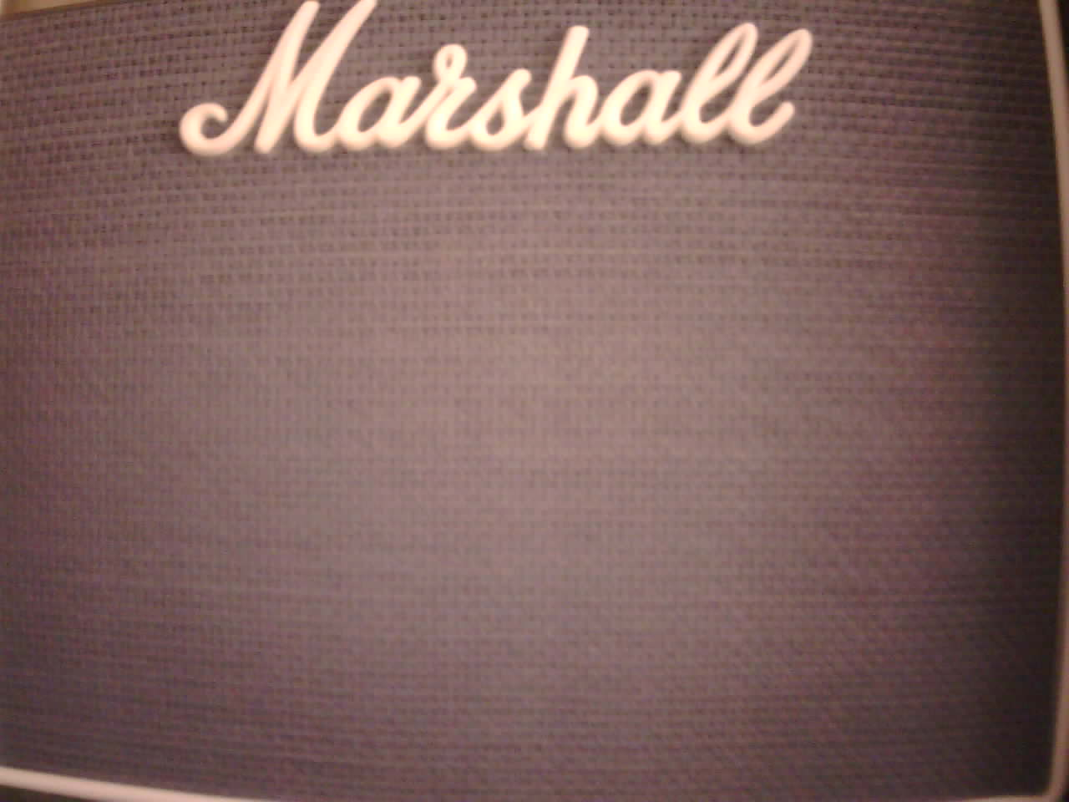
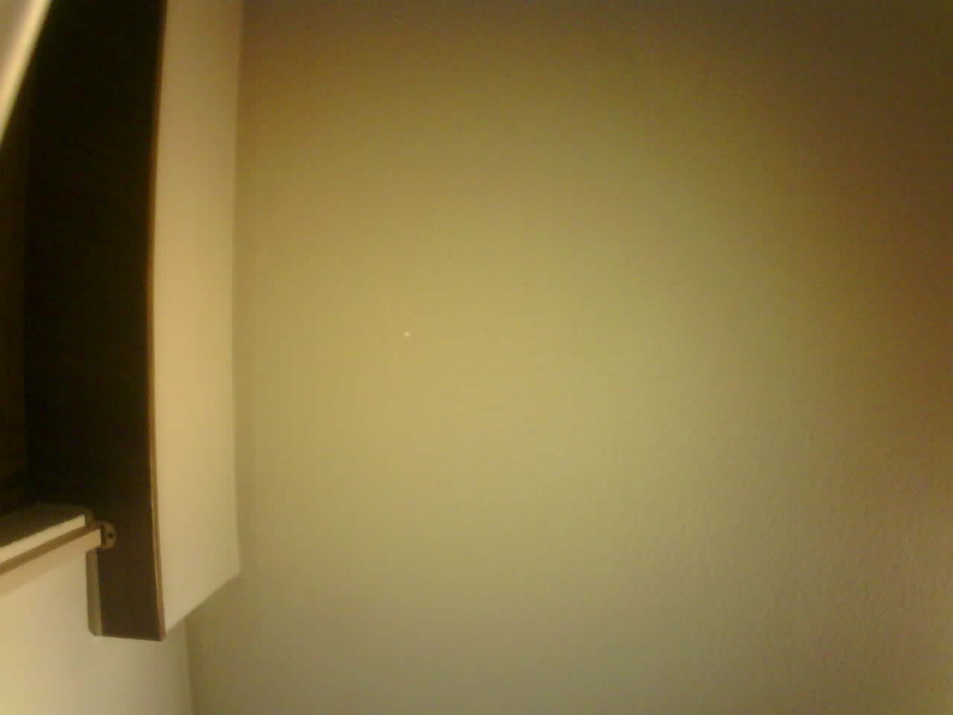
- Warm indoor lighting at night → Warm tint but visually reasonable;
- Natural daylight → Slight reddish-brown deviation.
The open-source project also provided parameter adjustment interfaces for image properties such as Contrast and Brightness. In theory, these parameters could further improve image appearance and detail representation.

However, considering that the core objective of this project is the embedded system and AI inference pipeline rather than camera ISP tuning, and that the current image quality has already satisfied the basic requirement of “target recognizability”, further debugging and adjustment of parameters such as contrast and brightness were not continued in this phase.

Phase Achievements
This phase focused on the core objective of:
Constructing embedded-side image output capability.
and successfully completed the key capability transition from input triggering to image acquisition.

The major achievements are summarized below:
Construction of the Input System
Completed the design and verification of the button-trigger mechanism:
  - Constructed a state-machine-based software debounce model;
  - Implemented: “Press + Release → Single Event Trigger”
  - Established observable output verification through LED toggling.

Successfully implemented:
Mechanical Button → Stable Software Event → System Response
providing the foundation for future image acquisition triggering.

Establishment of the Camera Control Path
Completed the construction of the low-level camera control framework:
  - I2C bus verification;
  - PCF8574 IO expansion control;
  - Camera PWDN power control path establishment;
  - SCCB communication implementation.

Successfully read the camera ID (0x2642), confirming:
The camera can be stably controlled by the MCU, and the control path has been fully established.

Upgrade of the Debugging Framework
Completed the transition from “UART print debugging” to “Debug-mode-based debugging”

Establishment of the Image Acquisition Path
Successfully constructed single-frame image acquisition capability:
  - Implemented DCMI + DMA Snapshot mode;
  - Established JPEG integrity verification mechanisms (SOI/EOI);
  - Successfully exported captured images to PC and verified usability.
Engineering Optimization of Image Quality
- Increased resolution to 1280 × 960;
- Enhanced image detail;
- Improved color behavior from “severe distortion” to “interpretable color deviation”.

Introduced Open-Source Projects
At critical stages, open-source projects were introduced as engineering references, including:
  - Camera initialization process;
  - Image output mode configuration;
  - DCMI hardware parameter settings;
  - JPEG acquisition logic.

Phase Conclusion
The objectives of this phase were successfully achieved.

The system completed a critical transition from “A simulated system without real input capability” to “An embedded vision system possessing real camera-based image input capability”

Specifically:
Layer | Result
Input Layer | Event-driven mechanism established
Control Layer | Camera controllable and communicable
Data Layer | Complete image acquisition path established
Debugging Layer | System became observable and diagnosable
Output Layer | Images reached engineering-level usability

Next Phase Direction
Based on the foundation established in this phase, the system will formally proceed into:
  - Integration of the button-triggered image capture system;
  - MCU → PC image transmission path;
  - Integration of image data into the AI inference pipeline.

The system will then continue evolving toward a complete embedded AI application system.

